Union County Fair Queen
T-Shirt Fundraiser Order Form
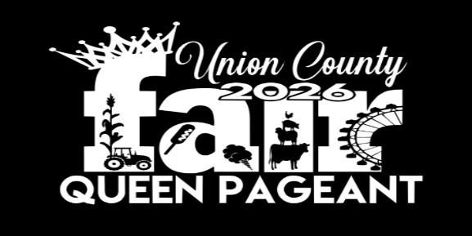
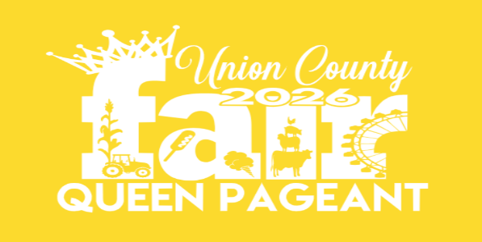
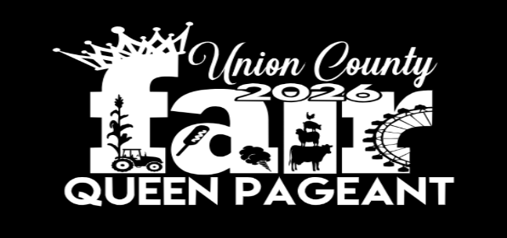
*A Biggest Fan Club award of $100 will be awarded to the contestant across all age divisions with the most T-shirt sales.*

Name:_____________________ Phone Number:___________________
Contestant Name:_____________________
Payment is due at the time the apparel is ordered
ADULT SIZES  $20.00 Ea. | Small | Medium | Large | Extra Large | 2XL Add  $3.00 | 3XL Add  $5.00
QUANTITY

YOUTH SIZES  $15.00 Ea. | SMALL  (6-8) | MEDIUM  (10-12) | LARGE  (14-16)
QUANTITY
FAN CLUB spots available for $10 each spot
Fan Club will be on the back of contestants’ shirt ONLY!!!
___________ ___________ ___________ ___________
___________ ___________ ___________ ___________
___________ ___________ ___________ ___________
___________ ___________ ___________ ___________

ORDERS DUE July 28th!!!!!!
***Each Contestant must sell 2 T-Shirts***
Make checks payable to Union County Fair
Total Amount Due:_______ Cash_______ Check#_______

